Practical - 13
Practical Title: 13: PHP JSON API and AJAX/Fetch-Based CRUD without Page Reload

Problem Definition: Create simple PHP JSON API endpoints for events or students and

consume them using Fetch API. Perform list, add, update, and delete

operations asynchronously without full page reload.

Theory

1. Do PHP endpoints return valid JSON responses?
ANSWER: Yes, the PHP API endpoint returns valid JSON responses containing student records retrieved from the MySQL database.

2. Are GET and POST requests handled properly?
ANSWER: Yes, GET requests are used to retrieve student records, while POST requests are used to perform Create, Update, and Delete operations.

3. Are loading, success, and error states shown on the frontend?
ANSWER: Yes, the frontend uses JavaScript to display appropriate messages for successful operations and errors, along with loading indicators where implemented.

4. Is input validation performed before database operations?
ANSWER: Yes, input validation is performed in PHP to check required fields, valid email addresses, field lengths, and valid student IDs before executing database operations.

Implementation/ Output/Result:

Evidence of Work (Screenshots):

Student Management System:
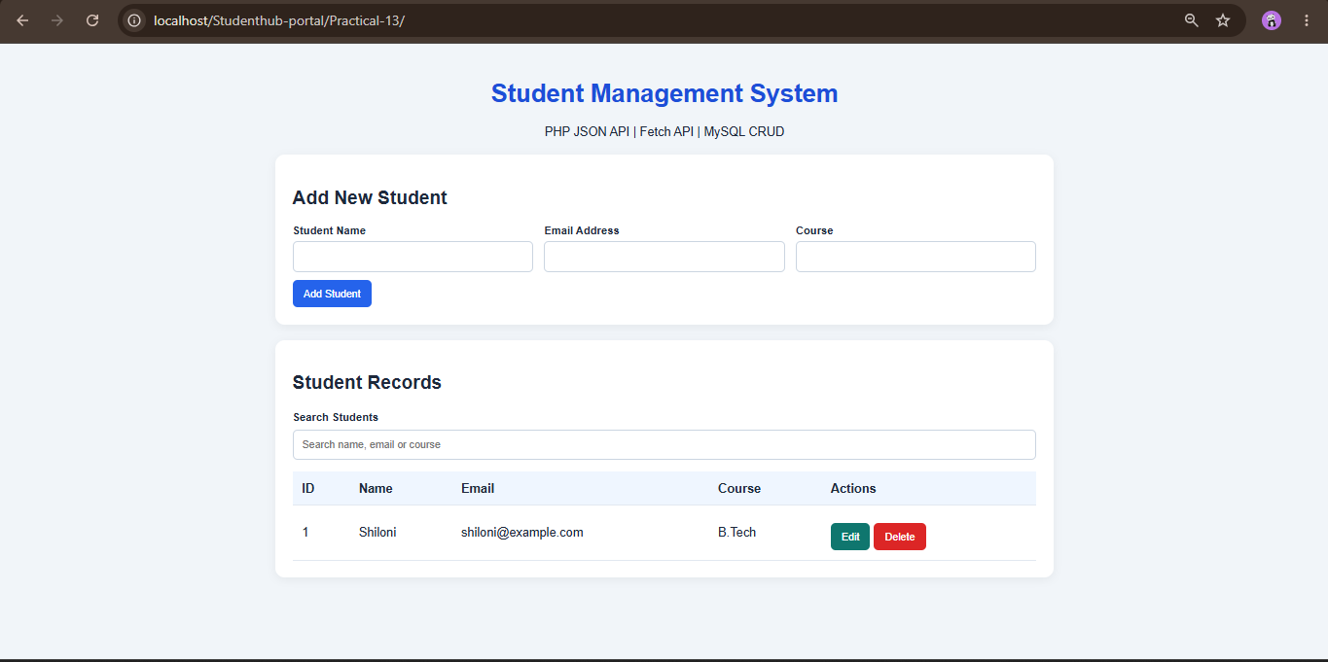

ADD the student:
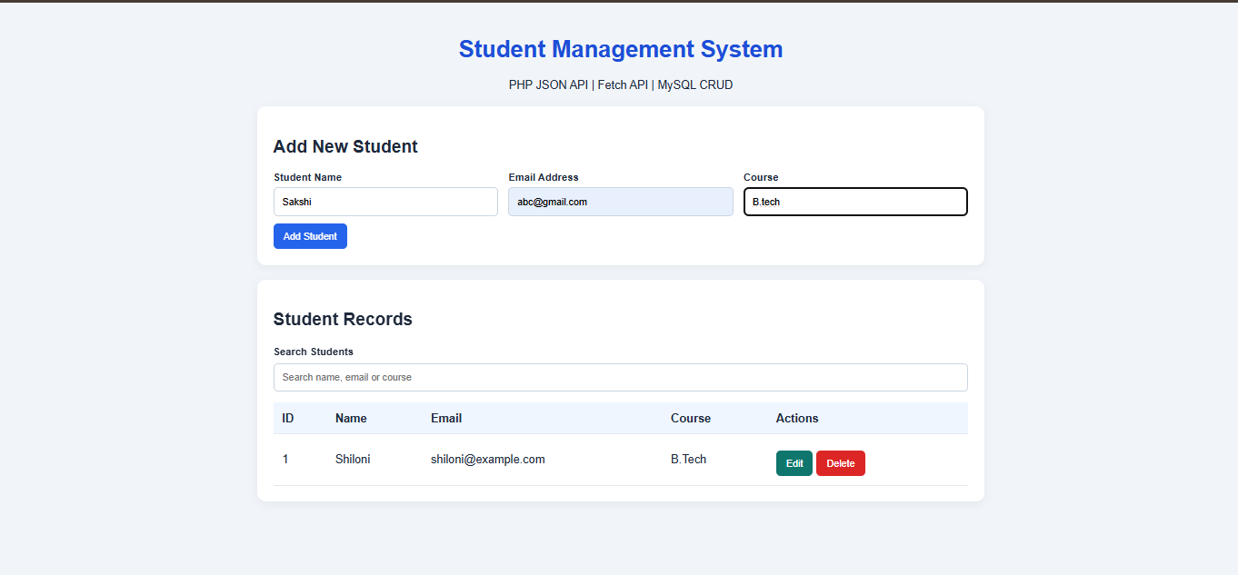
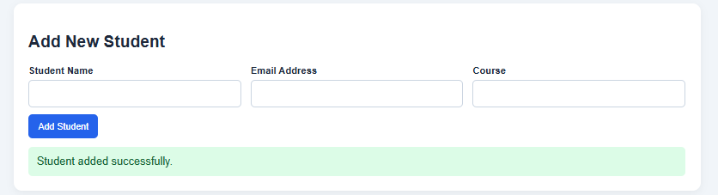

EDIT the student:
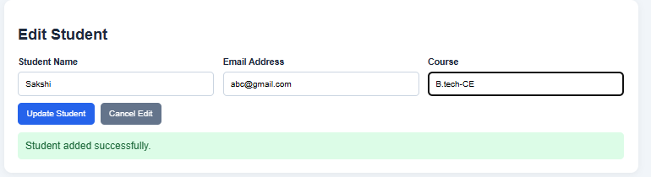

Searching the student by COURSE:
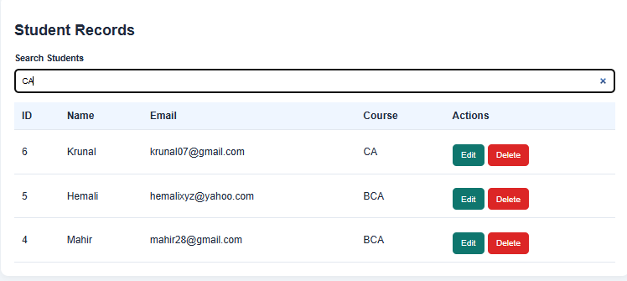

Student Records:
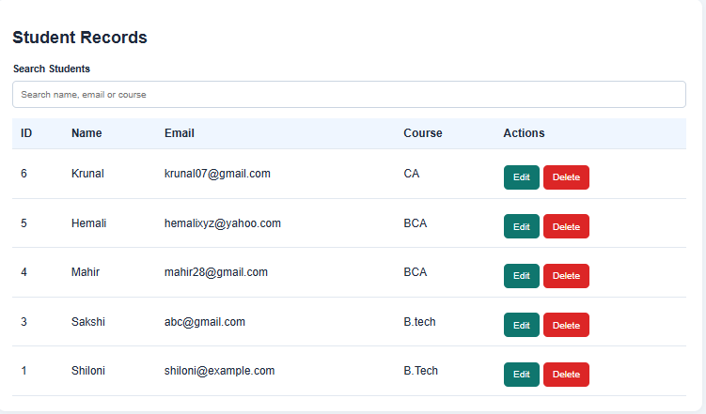

API fetch:
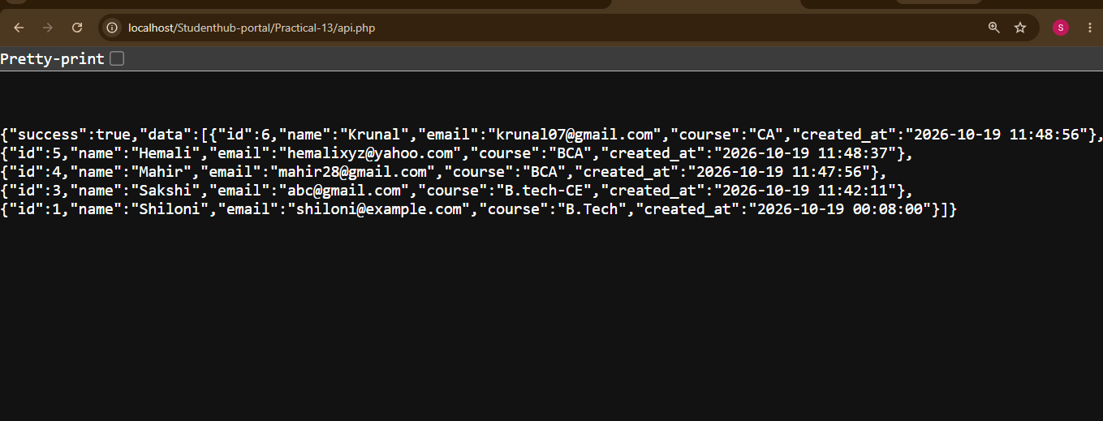

MYSQL:
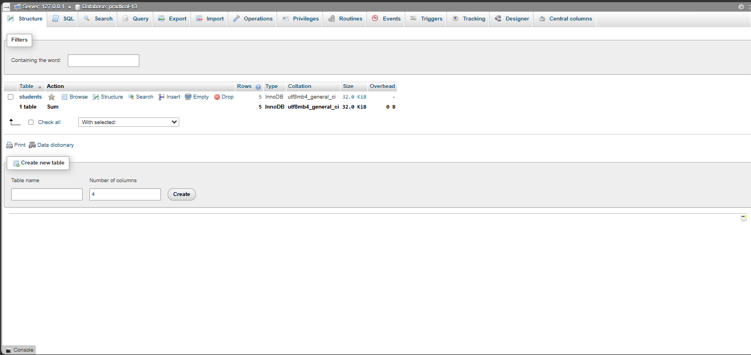
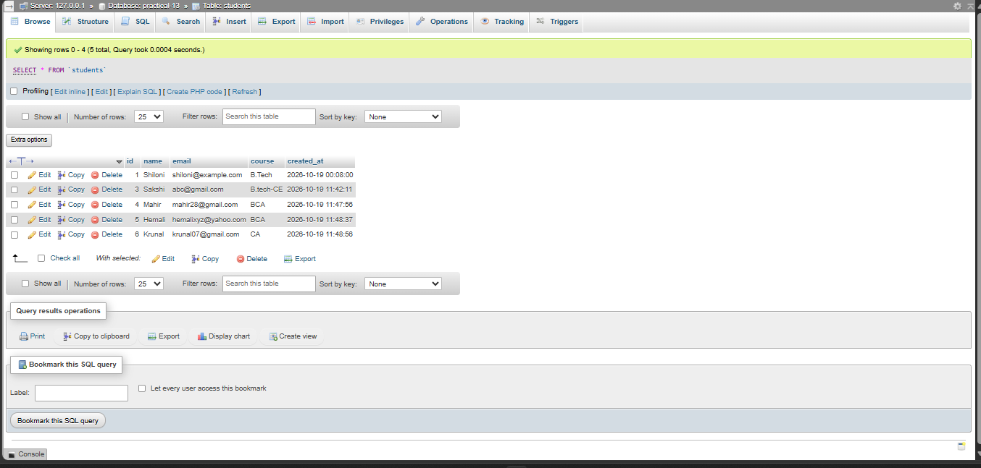

GitHub Repository Link:

https://github.com/shiloni28/WDF.git

E.Challenges Faced:

• Encountered a 403 Forbidden error while accessing the API endpoint.
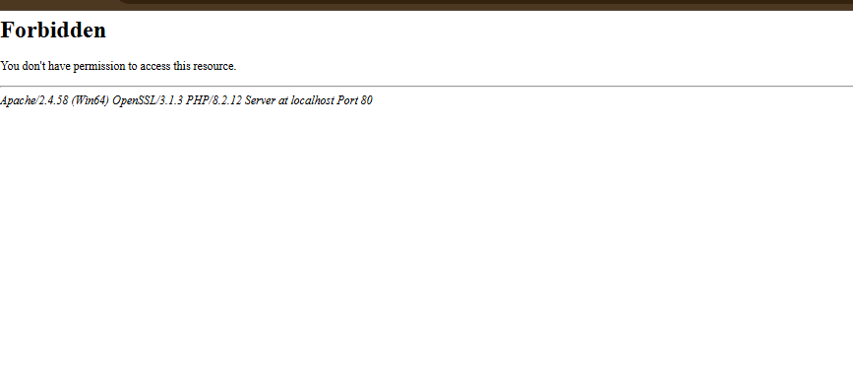

• Troubleshot API accessibility and checked the PHP file and Apache configuration.
• Configured the PHP application to connect to the correct MySQL database.
• Ensured that the API returned valid JSON rather than HTML or PHP error messages.
• Handled GET requests for retrieving student records.
• Implemented POST requests for creating, updating, and deleting student records.
• Resolved issues related to incorrect API URLs and file paths, if encountered.
• Validated required fields to prevent incomplete student records.
• Checked email formats and prevented duplicate email entries, if implemented.
• Handled invalid student IDs and requests for records that do not exist.
• Ensured that database queries used prepared statements.
• Ensured that the frontend correctly processed JSON responses from the PHP backend.

F.Learning Outcomes:

- Learned to create PHP API endpoints that return data in JSON format.
- Understood how to integrate frontend JavaScript with a PHP backend.
- Learned to use the JavaScript Fetch API to send asynchronous HTTP requests.
- Understood the difference between GET and POST requests.
- Implemented Create, Read, Update, and Delete (CRUD) operations for student records.
- Learned to retrieve student data from a MySQL database and display it dynamically.
- Understood how JSON data is transferred between the frontend and backend.
- Learned to validate user inputs before performing database operations.
- Understood how PHP handles API requests and generates appropriate responses.
- Tested the application with multiple student records to verify correct behavior.
- Learned to organize the application into separate frontend, API, and database connection files.
- Improved debugging skills by testing API endpoints and resolving access-related issues.
- Understood the importance of HTTP status codes in communicating API results.

Faculty Remarks:

